**TUGAS INDIVIDU**

**PEMROGRAMAN BERBASIS FRAMEWORK**

**PERTEMUAN 6**

Disusun oleh:

**Rijal Ammar Irsyadul Ibad**

**TI-3B/2041720184**

**D4 TEKNIK INFORMATIKA**

**TEKNOLOGI INFORMASI**

**POLITEKNIK NEGERI MALANG**

**2023**

1. Event Handler di Class Component Percobaan 1

Code:

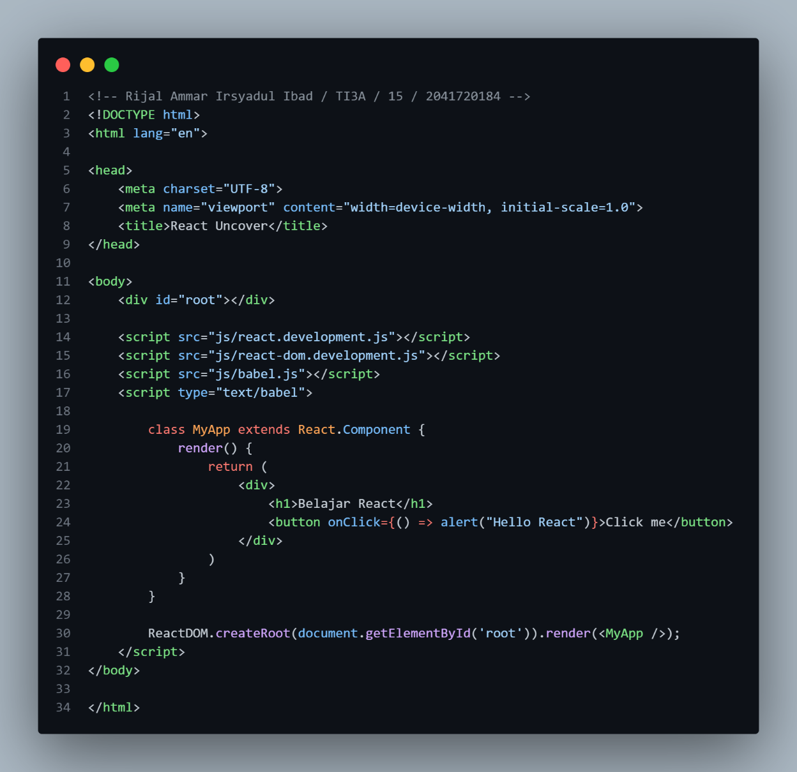

Hasil:

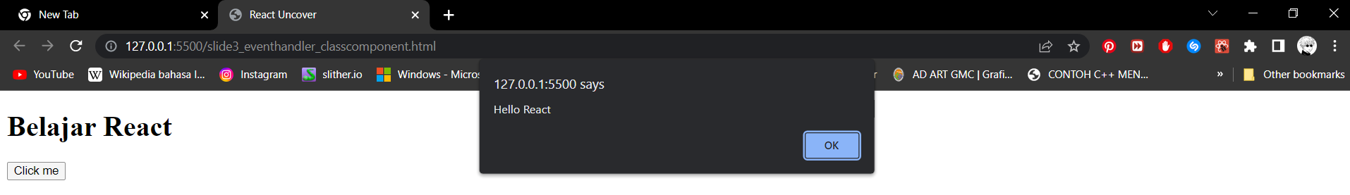

1. Event Handler di Class Component Percobaan 2

Code:

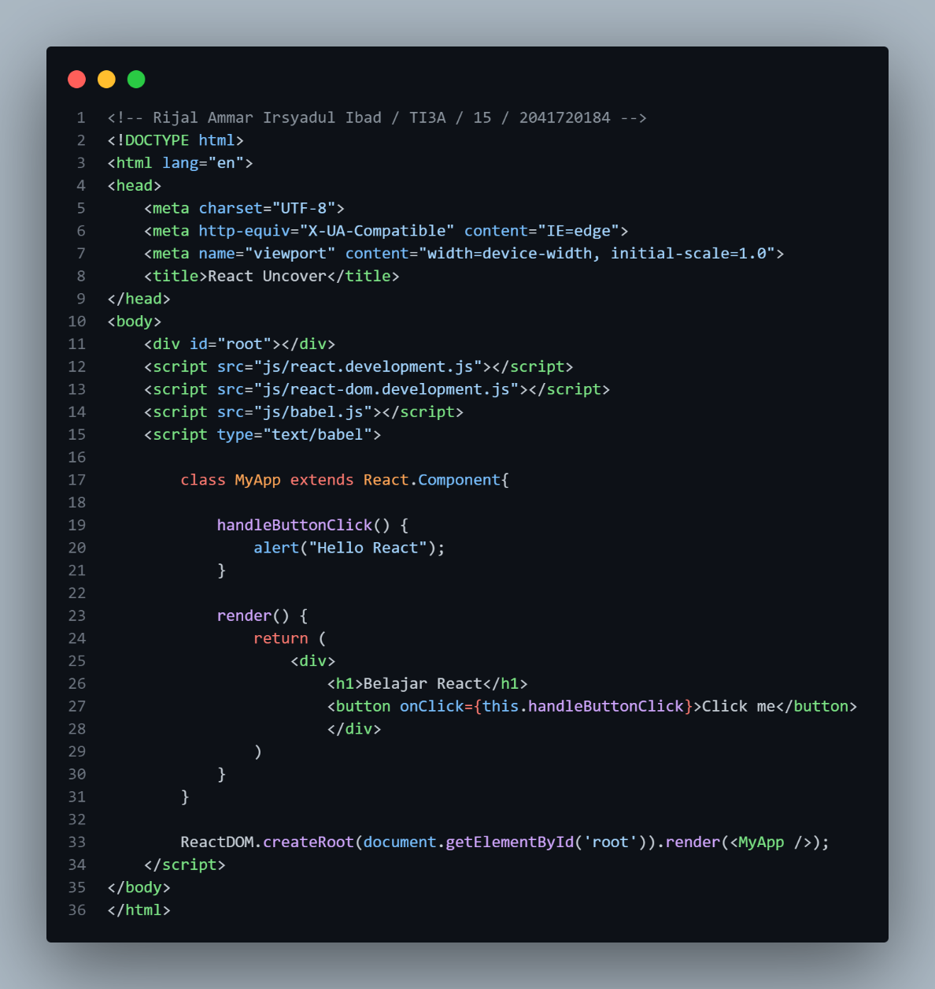

Hasil:

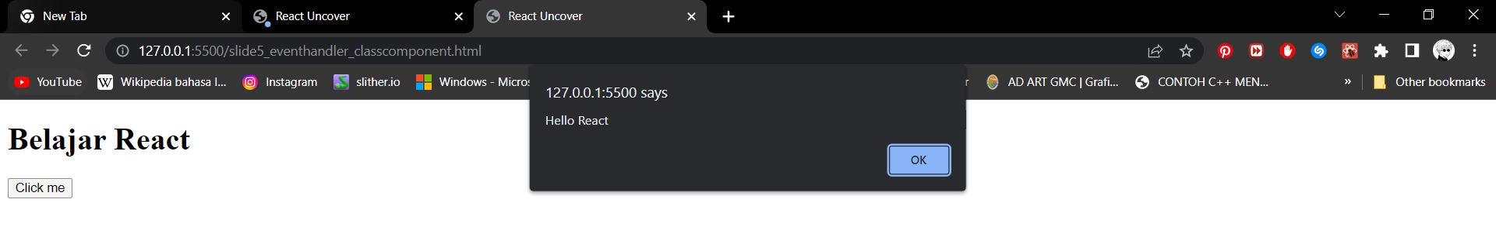

1. Event Handler di Class Component Percobaan 3

Code:

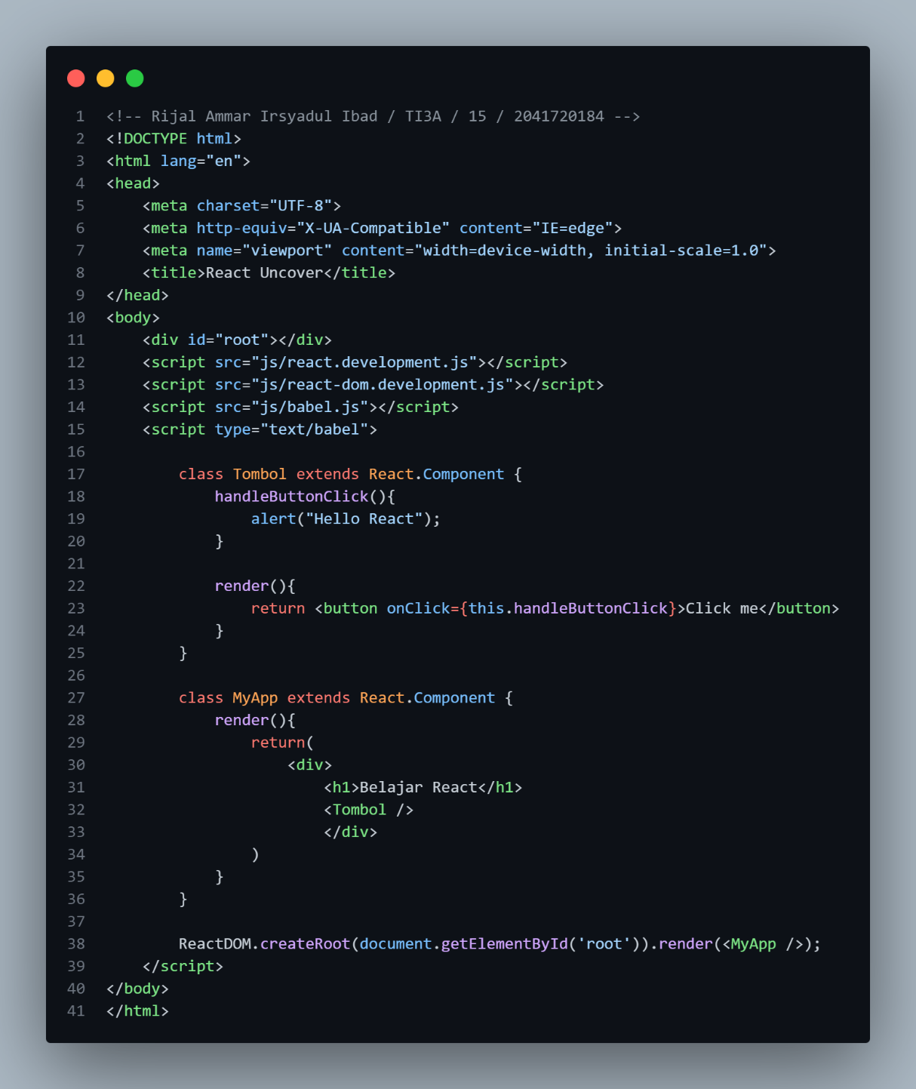

Hasil:

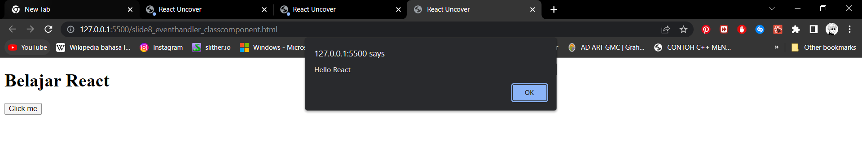

1. Event Binding Percobaan 1

Code:

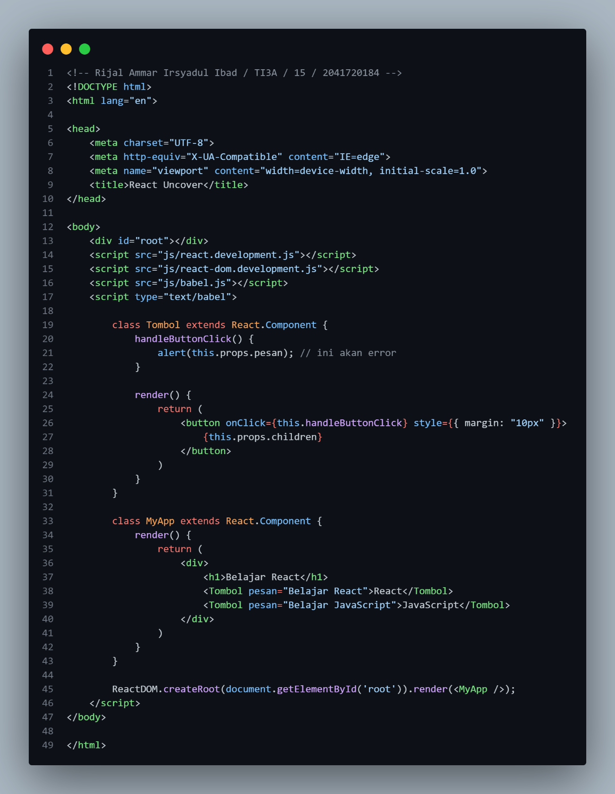

Hasil:

1. Event Binding Percobaan 2

Code:

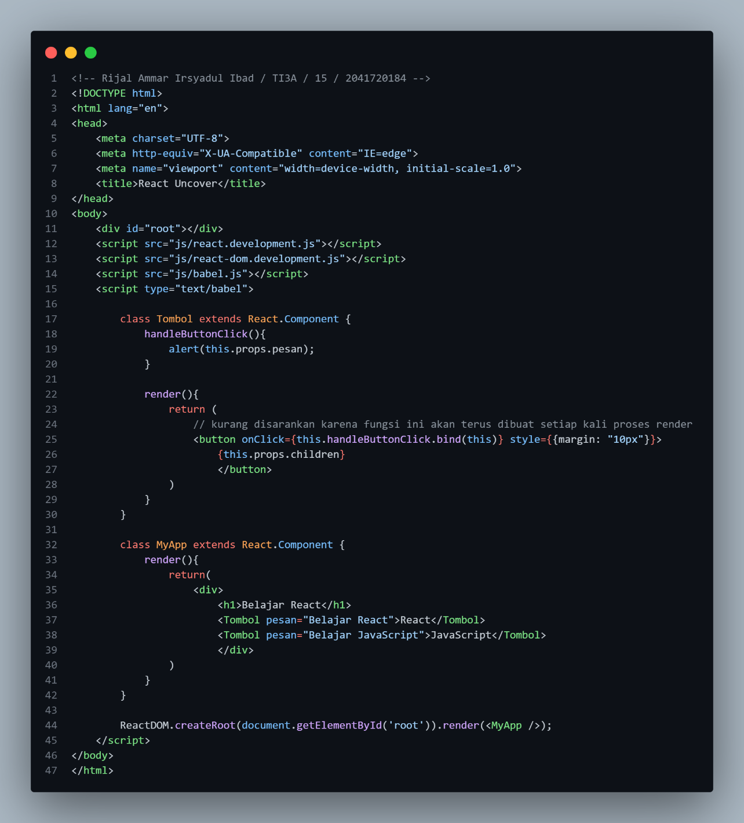

Hasil:

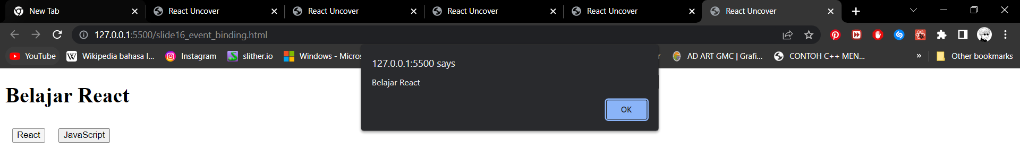

1. Event Binding Percobaan 3

Code:

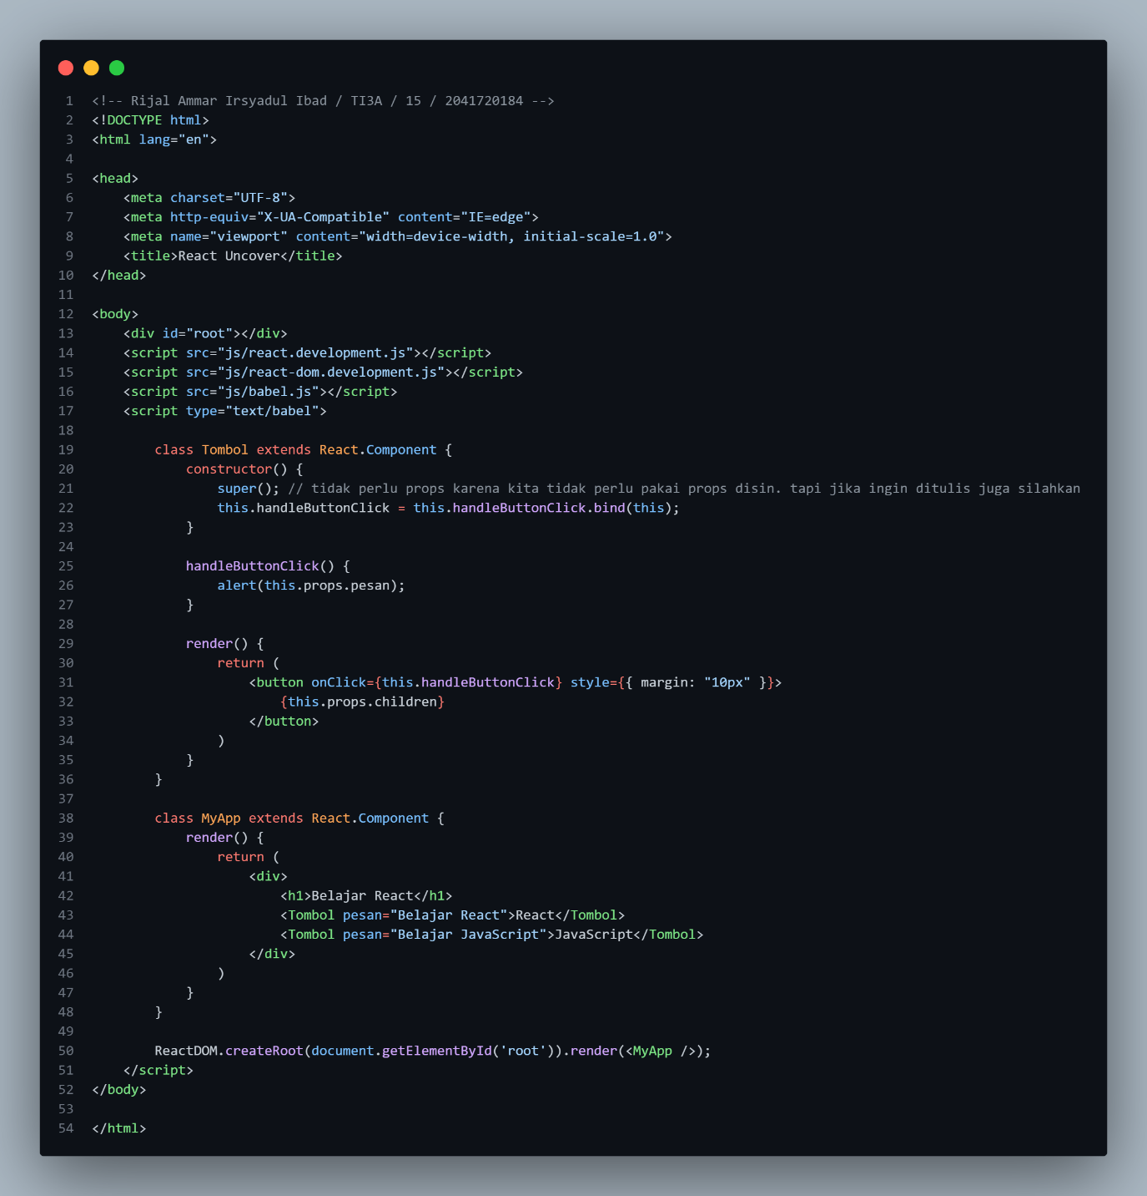

Hasil:

1. Event Binding Percobaan 4

Code:

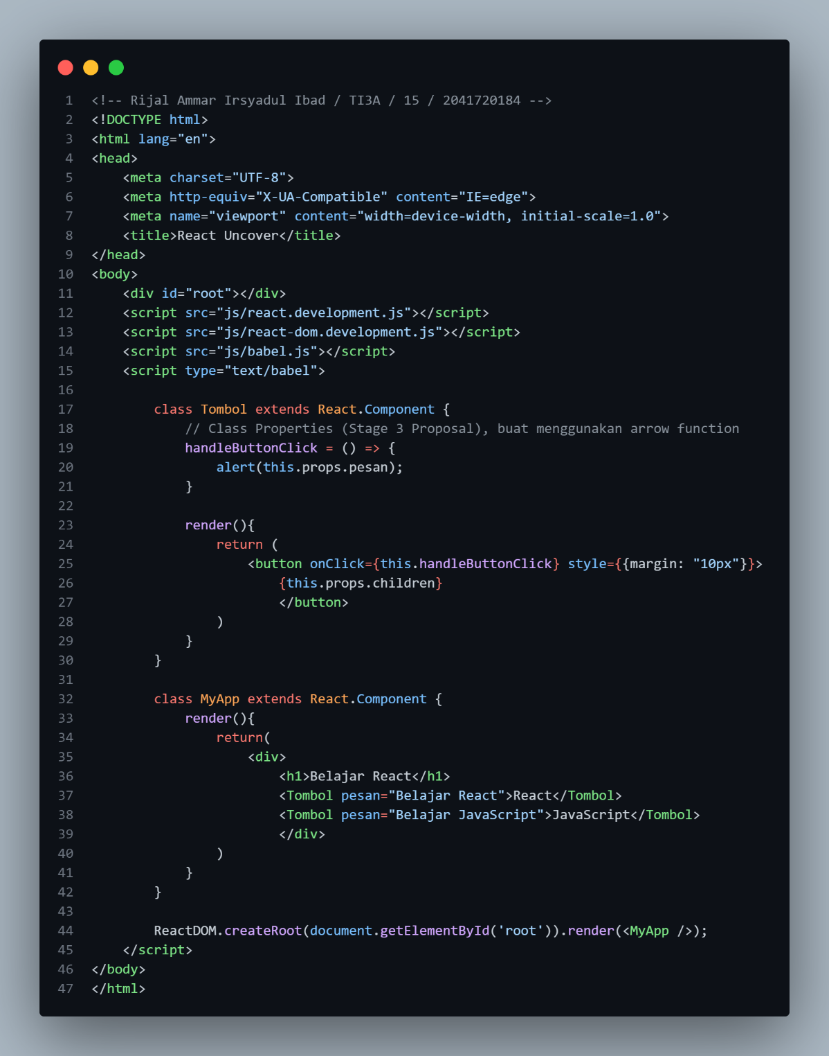

Hasil:

1. Event Binding Percobaan 5

Code:

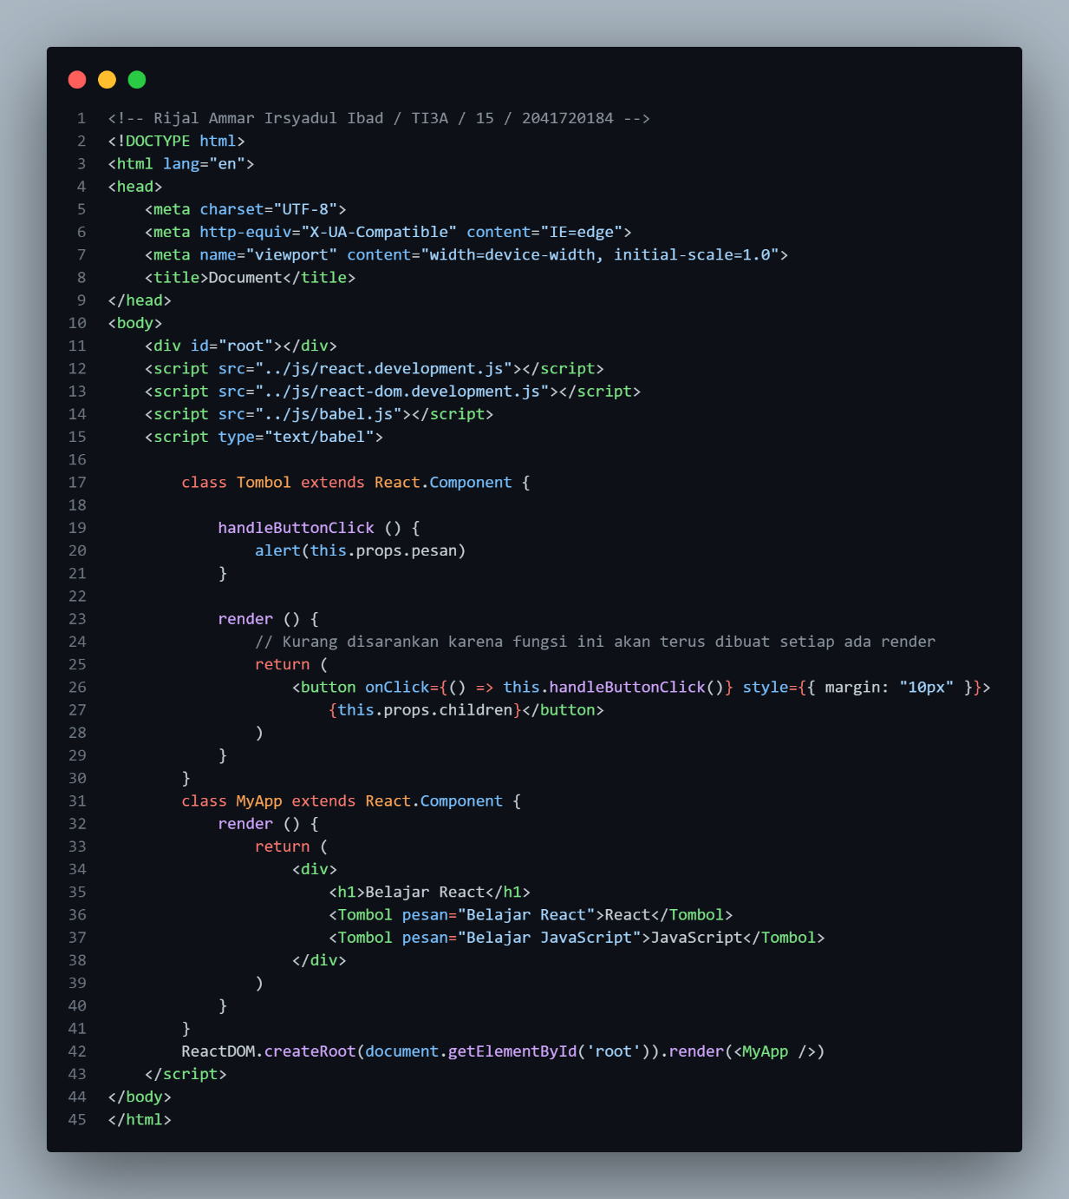

1. Event Object Percobaan 1

Code:

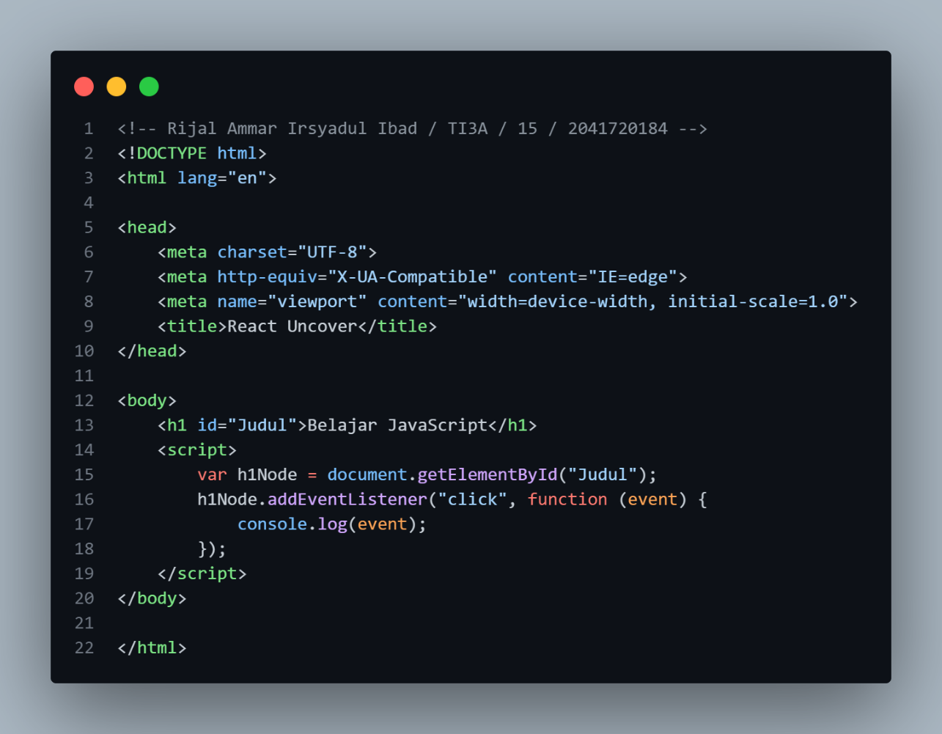

Hasil:

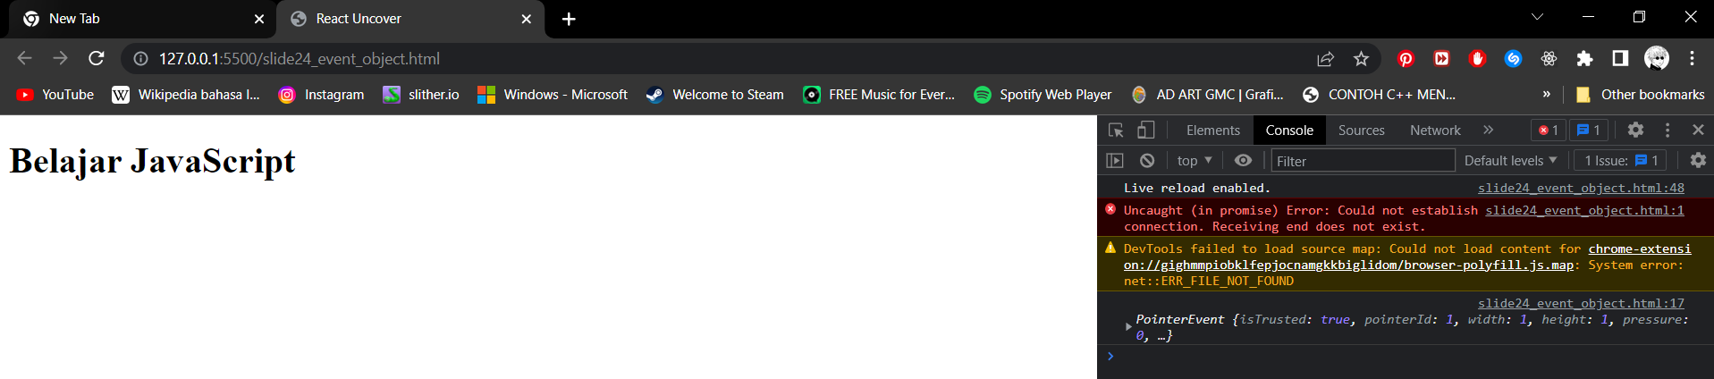

1. Event Object Percobaan 2

Code:

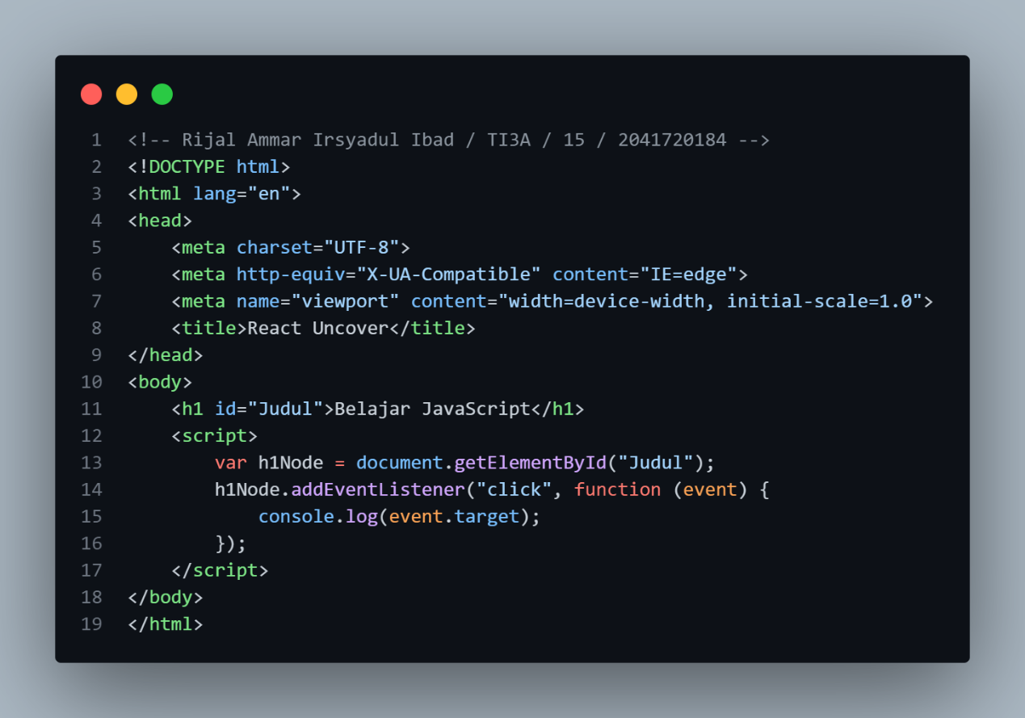

Hasil:

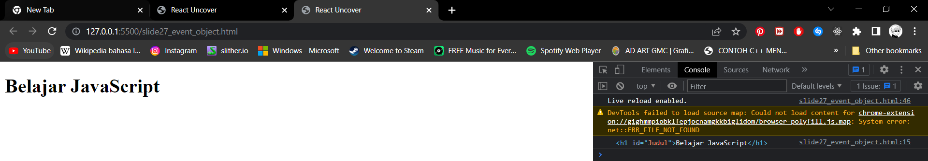

1. Event Object Percobaan 2

Code:

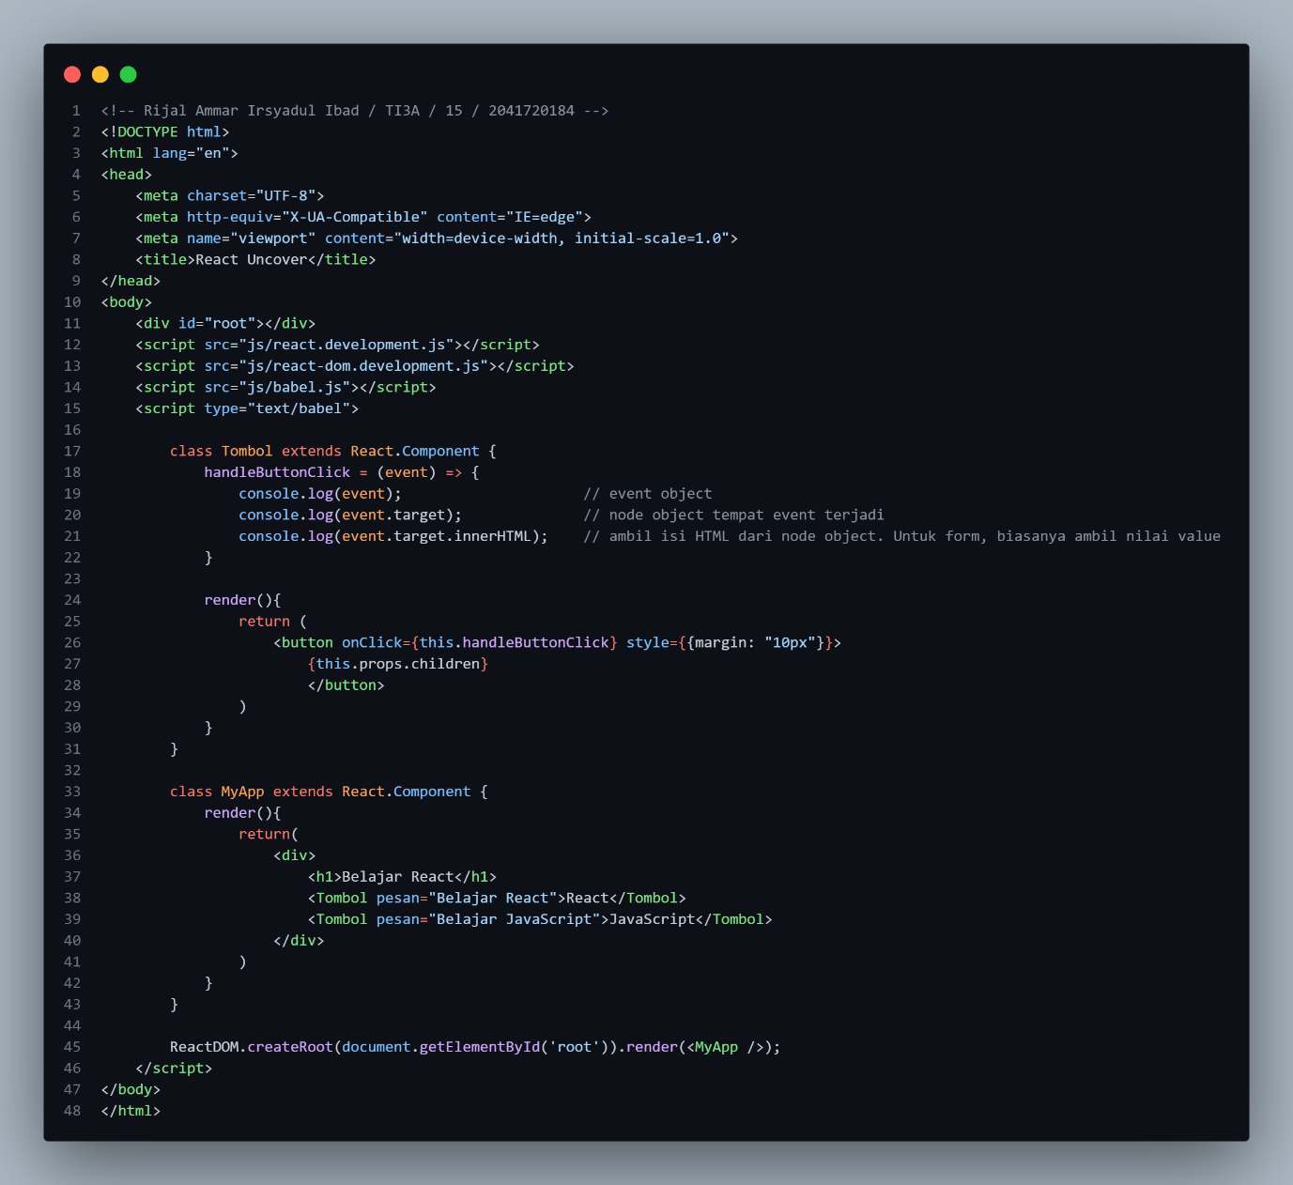

Hasil:

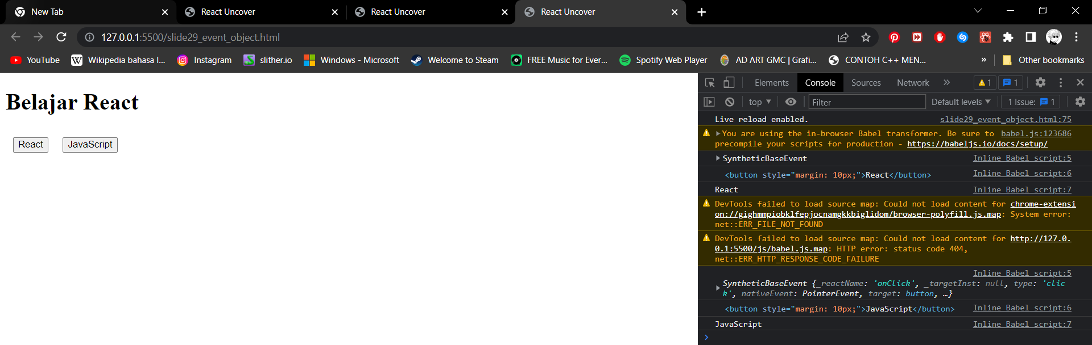

1. Menurunkan (Passing Down) Event Handler

Code:

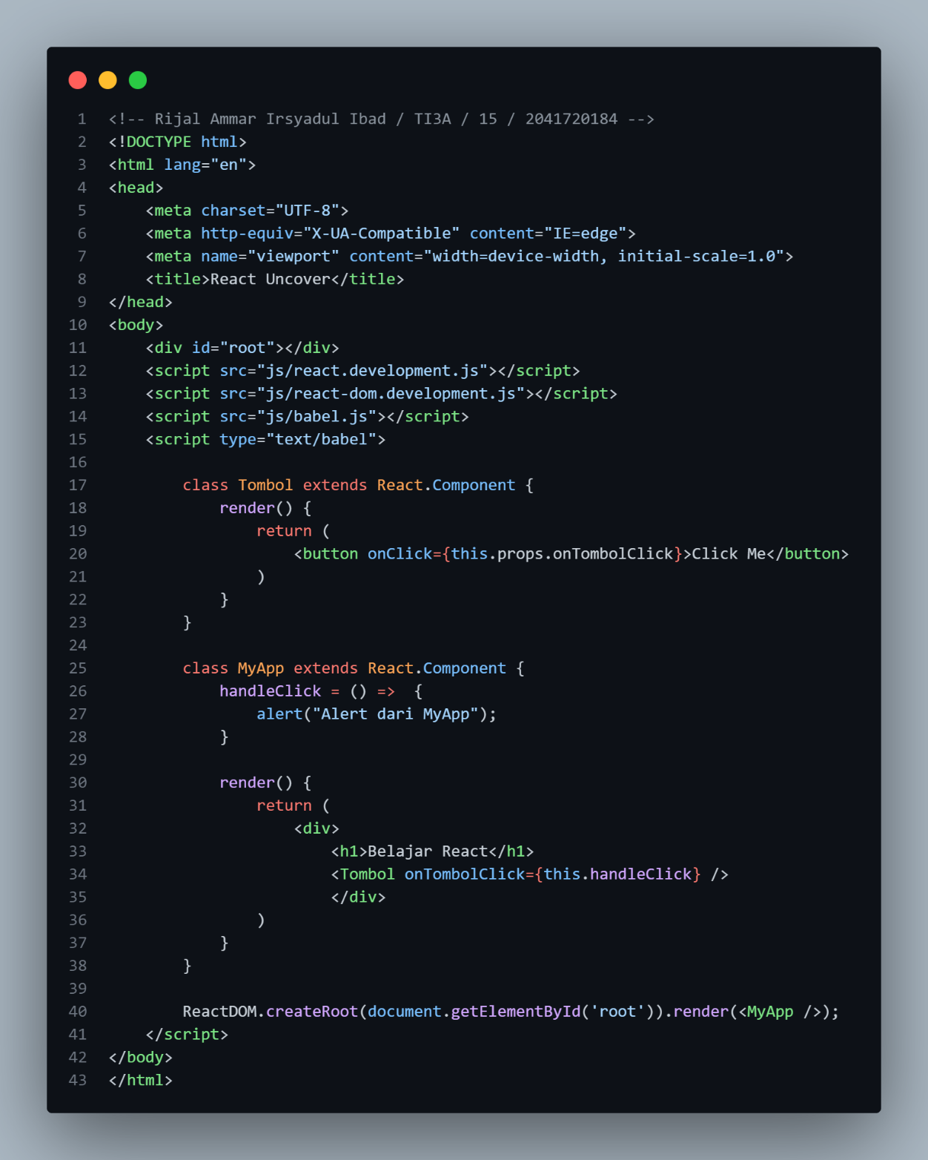

Hasil:

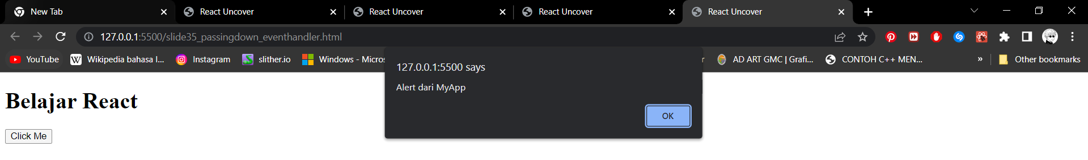

1. Menurunkan (Passing Down) Event Handler

Code:

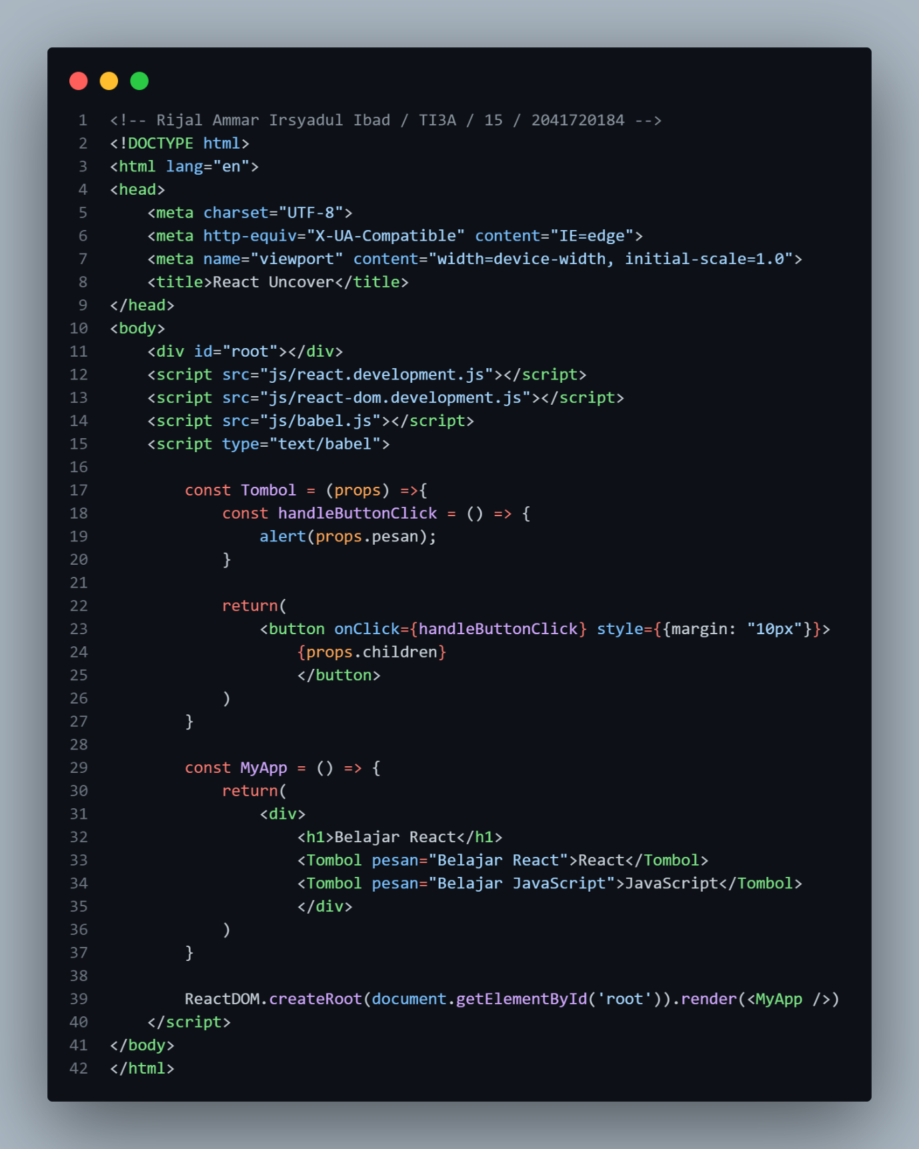

Hasil:

1. Tugas 1 PPT

Code:

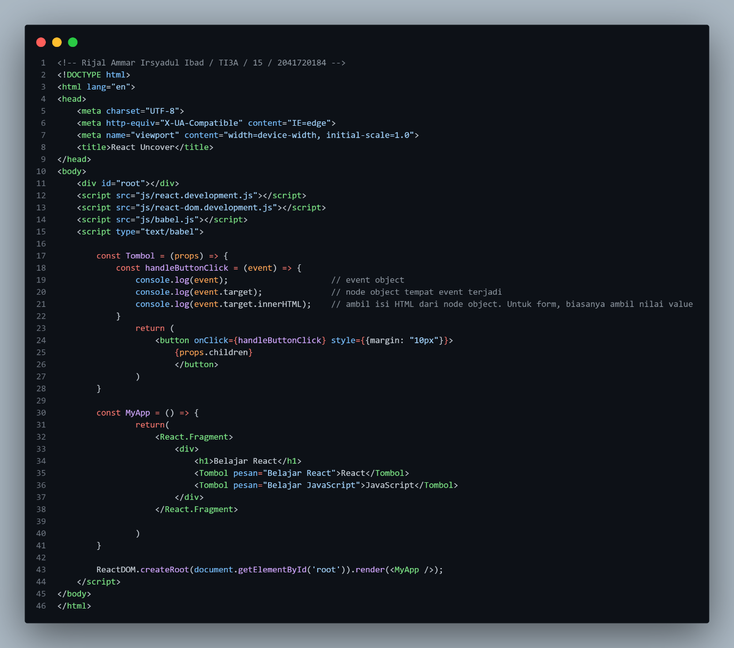

Hasil:

1. Tugas 2 PPT

Code:

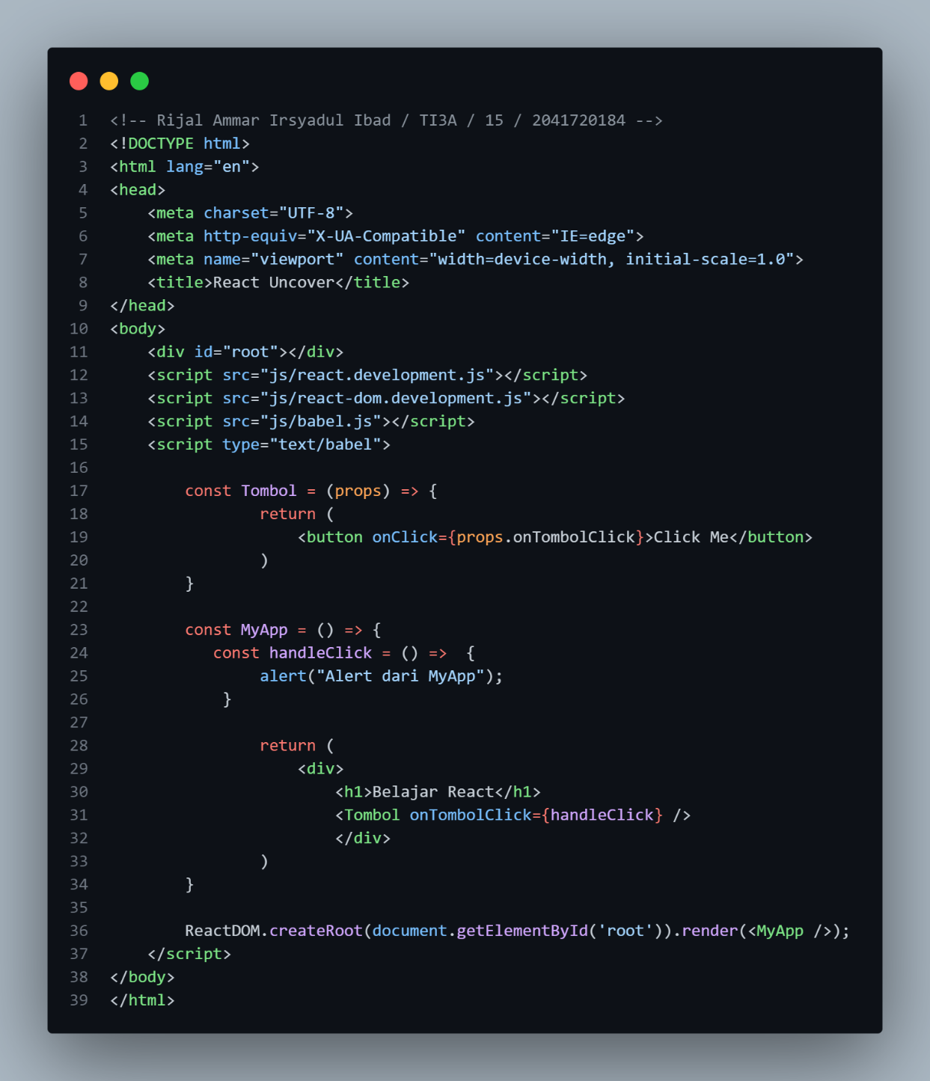

Hasil:

